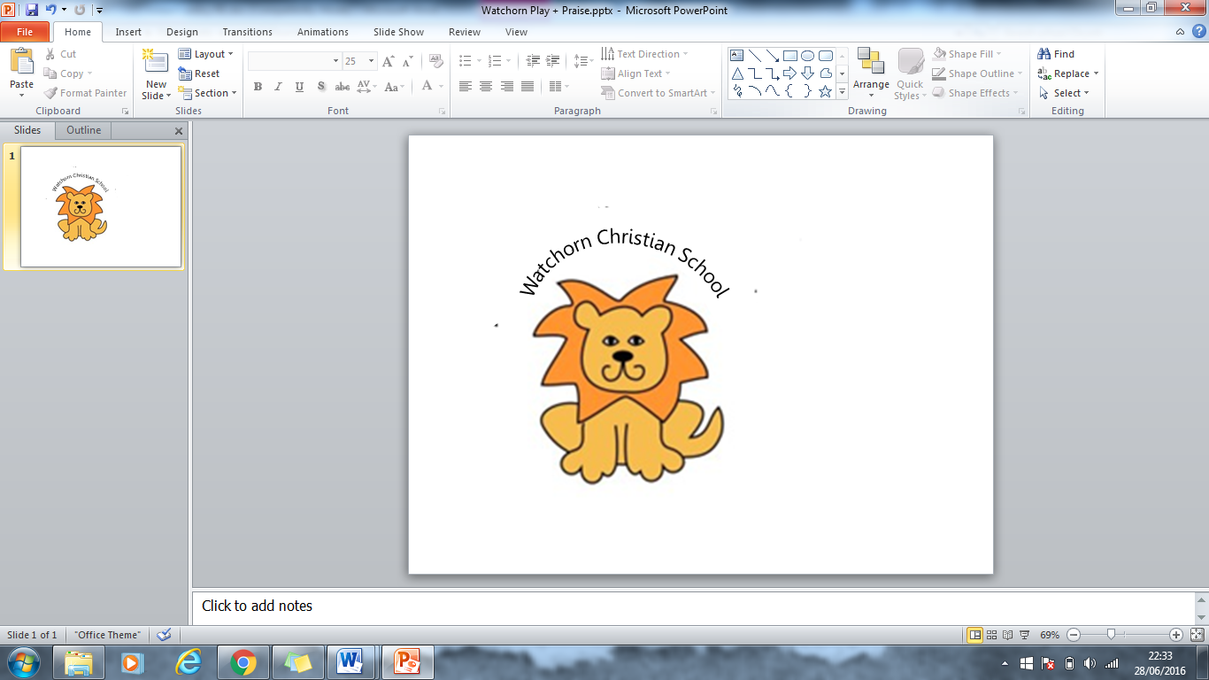Curriculum Subject Policy: English / Handwriting

**January 2021 review of handwriting**

At Watchorn School we believe in the importance of clear and neat presentation in order to communicate effectively. Following a review of handwriting, from January 2021 the following guidelines will be use.

Nursery and Reception will be taught how to form each letter individually to help with the correct letter formation.

Letter formation will be included as part of the daily phonics’ session. All, name cards key words or other writing activities for the children will indicate where the letter begins to aid childrens’ letter formation.

Children will start to progress to a joined-up script from the second term of Year 1 or once all letters are formed correctly.

Some letters are break letters. These will not be joined to the following letter (break letters are z, q and x ) and some letters g, y and j have a loop at the bottom to join to the next letter and x will be curved like two ‘c’.

g y j x

Pupils should be able to write legibly in both joined and printed styles with increasing fluency and speed by:

• Having correct pencil grip

• Knowing all letters start from the top, except d and e which start from the middle

• Forming all letters correctly

• Knowing the size and orientation of letters.

**Watchorn School will use the following letter and number formation**

A b c d e __ g h ij __ l m n o p q r s t u v w ____ z

A B C D E F G H I J K L M N O P Q R S T U V W X Y Z

1 2 3 __ 5 6 7 8 9 10

**Teaching time**

Handwriting practise should happen three times a week. Included in this there should be a taught session (to include teacher modelling). Some children will be targeted for more intensive intervention.

Children will be taught the 4 basic joins

1. To letters with ascenders

2. To letters without ascenders

3. Horizontal joins

4. Horizontal joins to letters with ascenders and descenders

When first starting to join up the children will follow the pattern of letters outlined in the appendix

**Handwriting books**

In Reception and Year 1, children use small plain or lined books, depending on ability.

In Year 2 and in key stage 2 pupils use A5 handwriting books with 4 lines which give guidance for correct height of ascenders and descenders.

**Getting ready to write**

Seating and posture

• Chair and table should be at a comfortable height

• Encourage children to sit up straight and not slouch

• Left hand should be used to steady the paper for right handers

• Tables free of clutter

• Room well lit

• The paper should be placed to the right, slightly tilted to the left

Left handers:

• Paper should be tilted to the right

• Right hand should be used to steady the paper

• Left handers may need to use a different pen to avoid smudging on the page (See SENCO for resources)

• Left-handed pupils should sit to the left of their partners

**Pencil grip:**

• Children should write with a pencil (or pen in upper KS2) with a rounded nib.

Pencils should be sharp.

• A tripod grip is the most efficient way of using a pencil and should be encouraged in early writing.

**A Getting ready for writing rhyme**

1,2,3,4 are your feet flat on the floor?

5,6,7,8 make your back nice and straight,

9,10,11,12 this is how our pencil’s held,

13,14,15,16 now we’re ready for our writing!

**Assessment**

• Is the writing legible?

• Are letters correctly shaped and proportioned?

• Are joins made correctly?

• Are spaces between letters, words and lines appropriate?

• Is size of writing appropriate?

Children should be observed as they write during handwriting sessions – the teacher should circulate, monitor and intervene.

**Appendix 1**

In the **Foundation stage** handwriting will be implemented as follows:

• Children will develop hand eye co-ordination, gross and fine motor skills to support handwriting.

• Children will use a range of tools to develop drawing lines and circles using gross motorskills e.g. swirling ribbons, batting balls, painting.

• Children will use a range of materials to develop fine motor skills e.g. wax crayons, markers, pencils, sponges, chunky brushes, cotton wool balls, shaving foam, finger paints, etc.

• Children will practice manipulative skills e.g. cooking, playing with constructions, threading and playing instruments.

• Children will use variety of tools and paper, indoors and outdoors for purposeful writing. e.g. role play, labelling, making cards.

• Children will physically develop the movements of letter shapes using gross motor skills (linked to music and sounds) to gain confidence with the basic movements and flow of writing.

• Children will be introduced to letters in line with their Letters and Sounds Phonics programme. The children will be taught where the letter starts and correct letter formation. Handwriting will be further embedded by teachers when they are carrying out the daily Phonics session.

• Children will be taught to form letters, using a variety of strategies and materials.

• Children will be taught how to join letters correctly.

• Parents will be given opportunities to support their child to practise their letter formation at home. Teachers will send home materials to enable parents to do this.

**Supporting activities**

• tracing patterns

• tracing

• copying over (letters, numbers and words)

• copying under (letters, numbers and words)

In **Year 1** Children to have handwriting practise of the ‘letter formation families’ . These can be taught alongside phonics

• i l t

• r n m

• h b p

• c a d g o q

• e s f

• u y j k

• v w x z

**Joins Y2** (going into Y3) Introduction of the four handwriting joins

• First join-To letters with ascenders; it, et, ut, at, ill, ell, all, ull and diagraphs

ch sh th ll

To be practised as rhyming strings with **no join** from the first letter

e.g sit, bit, lit kit

bet, set, jet, met

but, cut, hut

at, sat, bat, hat, mat

ill, pill, hill, till, bill, will

all, ball, hall, call, wall ,tall

ull,full,bull,hull,lull

• Second join- To letters without ascenders; un an in en, er um

• Third join- letters with wave joins (forward and back curve) and horizontal joins e.g. c,a,o, re ve oon oom

Oon, moon, soon, etc

• Fourth join- Horizontal joins to letters with ascenders and descenders ; ad ,ag, ap, ip, up, op, ool, oot,

• Practise the loop letters; g, y,j,

* Practise the break letters b q z x f

• Practise capital letters

**Supporting activities**

• Match and copy captions

• Trace and copy patterns

• Copy words

• Copy sentences

• Write out menu

• Copy poem

• Alphabetical ordering

**Joins Y3 (going into Y4) (handwriting can be part of the spelling pattern/phonics sounds e.g ound pattern ight, etc )**

Revision • Practise the break letters b p g q y j z

• Practise capital letters

Further practise of the four handwriting joins

• in ine

• ut ute

• ve vi

• ok oh

• sh as es

• ri ru ry (practising joining from the letter r)

• oa ad as (practising joining to and from the letter a)

• ee ea ed (practising joining from the letter)

• ow ov ox (practising joining from the letter o)

• ky hy ly (practising joining to the letter y)

• ha ta fa (practising joining to the letter a)

• od oo og( practising joining from the letter o)

• er ir ur (practising joining to the letter r)

• ai al ay

• o you oi

• re oe fe (practising the horizontal join to the letter e)

• fu wu vu (practising the horizontal join to the letter u)

• ot ol ok (practising joining to ascenders)

• ai al ow ol (practising all the joins)

Supporting activities

• copy words

• copy sentences

• copy poem

• match questions to answers

**Year 4**

• ning ping ting

• oc od oo

• ake ome are

• fla flo fle

• who wha whe

• ie in il

• inly ky ny

• ap ar an

• ick uck ack

• practise writing with a slope

• he

• we

• re

• fte fir fin

• wra wri kni (silent letters)

• ii ll tt rr nn mm cc oo dd ss ff ee

• ew ev ex (spacing)

• th ht fl (proportions)

• ac ag af

• Capital letters

• Decorated capital letters

• Practising with punctuation ! ? – “ “ , ‘

Supporting activities

• Copy words, sentences, poems

• Trace and copy

• Copy tongue twisters

• Copy instructions

Years 5 and 6

• Practise consistency and size of letters

• Practising using a diagonal joining line

• Practising leaving an equal space between letters

• Practising joining to the letter y

• Practising using a horizontal joining line

• Practising the size and height of letters

• Practising joining from the letter i

• Practising joining to and from the letter v

• Practising consistency in forming and joining letters

• Practise speedwriting

• Practising crossing double tt on completing the work

• Practising joining to and from the letter e

• Practising joining to and from the letter w

• Practising printing

• Practising drafting and editing

• Practising joining to the letter t

• Ensuring letters are consistent in height and size

• Practising with punctuation

• Practising break letters

• Practising joining from the letter m

• Ensuring the ascender on the letter t is the correct height

• Practising spacing within words

• Developing fluency

• Practising printing

• Practising forming and joining the letter f

• Practising presentation

• Practising speed writing

• Revision

• Looking at different handwriting styles

**This policy was reviewed by the schools Governing Body on 01/12/2021 and will be reviewed every other year.**