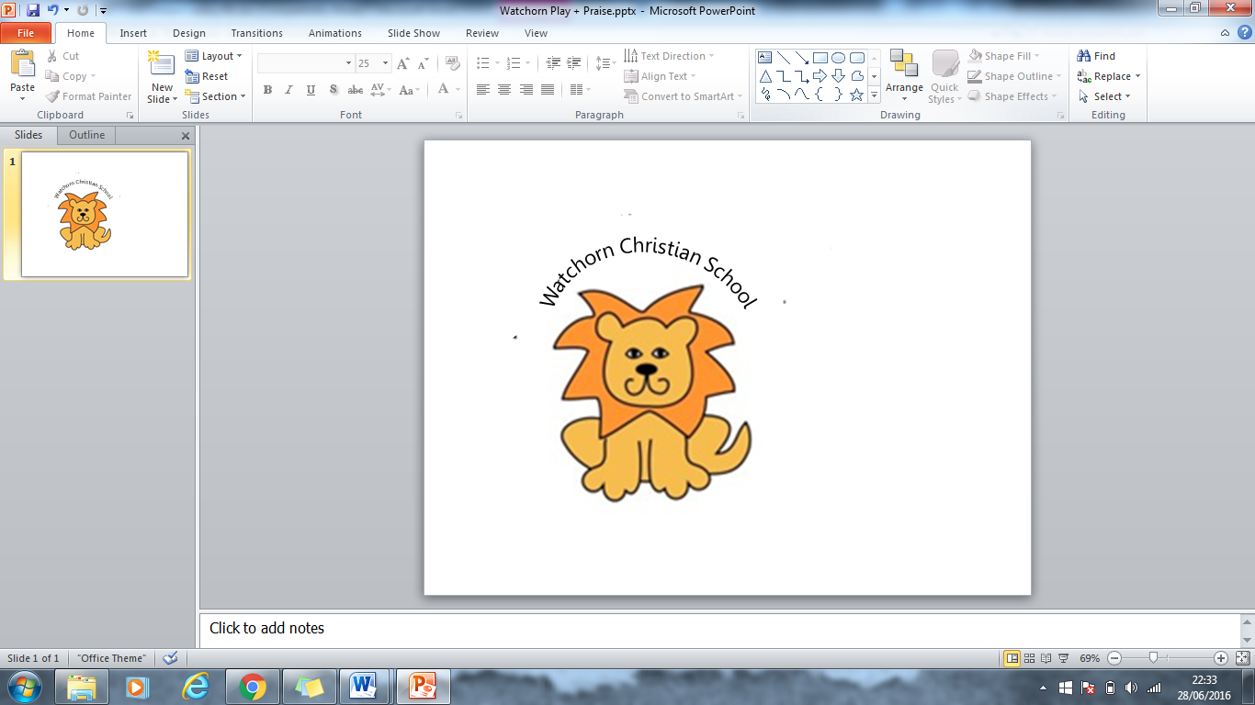
Curriculum Subject Policy: Physical Education

Introduction: As a Christian Independent School, our teaching aims to promote the Christian values of: courage, respect, truth, compassion, creativity, community and working hard. This is achieved through well planned curriculum content and the general school ethos which underpins learning.

P.E is an important subject at Watchorn Christian School as it allows children to learn in a different manner, being active and physical. It teaches children to look after their bodies and fosters a love of exercise from an early age. This policy outlines the vision for teaching, nature of the subject; implementation and assessment of P.E taught in our school and reinforces our Christian values.

Vision for teaching: Physical activity makes a valuable contribution to the whole school curriculum. Pupils are involved in developing their skills, knowledge and understanding within a range of physical activities so that they can perform with increasing competence and confidence. Physical activity provides the opportunity for pupils to be creative, competitive and work together cooperatively in a variety of different contexts. Physical activity encourages spiritual, moral, social, mental and cultural development alongside personal growth in terms of self-confidence and self-esteem. Physical activity teaches pupils the importance of regular exercise and its contribution to a healthy lifestyle. We aim for our P.E lessons to allow all abilities to succeed through a process of developing movement skills. It aims to strengthen skills of working together, building friendships, communication and following rules.

Implementation: In the Foundation Stage, physical education is termed Physical Development and focuses on improving both fine and gross motor skills. The children have a variety of resources outside to improve their physical development, such as balance boards, balls, stepping stones, hoops, skipping ropes and dance ribbons. Fine motor skills are also targeted in the outdoor environment through painting with water on fences, doing large scale weaving with ribbon and mark making in the mud kitchen with sticks. Physical development is a prime area of the EYFS as it underpins all other learning and is crucial for holding pencils correctly and forming letters with control.
In Key Stage one, the children have P.E lessons weekly, following the Do, Think, Feel Plans. The plans teach Athletics, invasion games, dance, gymnastics, dodgeball, striking and fielding games, net and wall games.
All areas of P.E are progressive throughout the year groups building on previously developed skills and knowledge. They encourage children to work individually, in groups and in teams to develop a range of skills including team work and communication.
The lesson plans are differentiated to allow children of all abilities to achieve success.
Emphasis is not only placed on the children’s physical demonstration (Do) of Physical Education but also on their understanding of tactical awareness, rules and physical understanding (Think) and understanding of social and emotional responses to taking part in Physical Education (Feel). Lessons place an emphasis on Do, Think and Feel because it enables children who are not naturally gifted to excel in P.E the opportunity to show understanding and excel on different levels within the context of P.E and truly include all children into the subject of P.E.

Competitions and fixtures:
The school affiliates with Amber Valley School Sport Partnership (AVSSP) which gains the school entry to local competitions and events. The children have the opportunity to represent the school in a variety of games, dance and gymnastics competitions. The affiliation also allows for the school to benefit from local feeder club information. Aside from the competitions and events run by AVSSP, the school will take part in localised fixtures playing friendly matches against other schools in a variety of games.

Extra-curricular activities:
When the children reach KS1 they are invited to take part in a weekly afterschool club run by specialist sports coaches offered by AVSSP.

Assessment:
Children will be assessed through the Do, Think, Feel resources. The assessment will take place weekly, based on the lessons learning outcome, this information will then be gathered to attain an overall description of understanding for each area of P.E. From the information children will be shown to be Exceeding, Emerging or Expected.
This information will then be used each year to write a report for parents.
All areas of P.E will be assessed. Children will be able to demonstrate understanding in these areas in a variety of ways including verbal feedback and written report.

Monitor and evaluate:
The SLT monitors the subject through observations and drop-ins, work scrutiny, planning scrutiny and pupil voice. The information gathered is fed back to all staff and relevant actions taken, if required.

Review:

This policy was reviewed by the schools Governing Body on 01/12/2021 and will be reviewed every other year.

