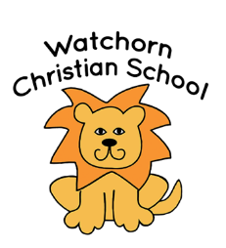
Lunch Policy

Aim
It is the school’s intention to ensure that every child
- enjoys and is thankful for the food they receive
- can eat sufficient healthy food during the day to sustain them
- learns what is meant by a healthy balanced diet
- is encouraged not to waste what God has given us.

Policy
- Children will be encouraged to eat whatever they bring in their lunch box. A principle of ‘learning to like’ will be adopted. Where food remains uneaten it will be returned in the lunch box so that parents are aware of what the child is eating.

- Lunch should consist of:
  - Sandwiches or other savoury food (appropriate quantity to be judged by the parent)
  - Fruit/vegetables
  - Chocolate biscuit/biscuit/cake (1 piece only)
  - In addition, a yoghurt/mousse, fruit/muesli bar, crisps (we discourage too regular use of crisps owing to the high salt and fat content) may be supplied.
- The children will be encouraged to eat savory food first, followed by fruit/yoghurt and the sweet part of their lunch.
- Adequate drink (not fizzy) should be supplied for the day and children will be encouraged to drink this at break and lunch time.
- Children will be provided with a piece of fruit at break time (A contribution of 20p a day is requested to help with the cost)
- Chocolate or sweets should not be sent unless these are for sharing with the class for a special occasion.
- Children will receive a sticker on their healthy lunch sticker chart if they bring 2 pieces of fruit/vegetables in their lunch box that day. The stickers result in a small prize when the chart is full.
- Lunch boxes are stored outside the classroom.

This policy was reviewed by the schools Governing Body on 01/10/2023 and will be reviewed every other year.

