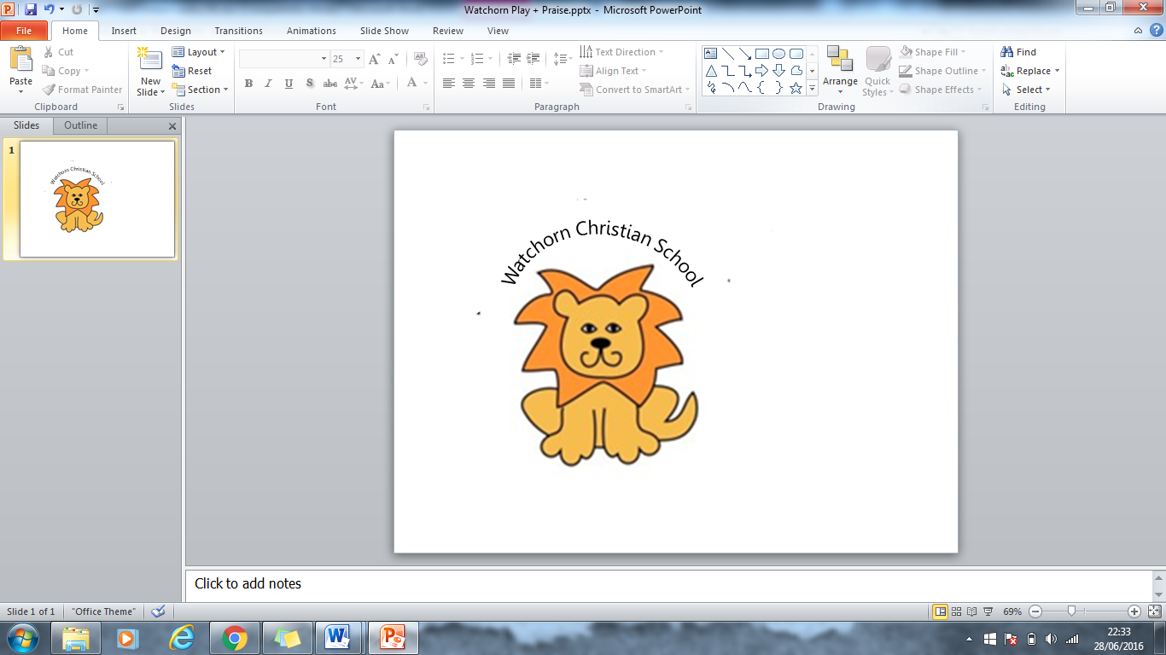

Staff Recruitment and Screening Policy

Watchorn Christian School are committed to creating an environment, which is safe for pupils, teachers and parents/carers to be in. As a result, we adopt recruitment procedures that will help deter, reject or identify people who might abuse children.
We have written our Staff Recruitment and Screening Policy using guidance from the 2018 Working Together to Safeguard Children and Keeping Children Safe in Education (Sept 2023).

Prior to the confirmation of the appointment of all staff, the following procedure will be followed to determine a person’s suitability:

- When a vacancy arises at the school an advertisement will be placed on the church website and may be advertised wider afield depending on the nature of the vacancy. In all detailed job descriptions and person specifications reference will be made to the responsibilities for safeguarding and promoting the welfare of children having regard to KCSIE (September 2023).
- An application form will be completed and submitted to the school. An accompanying letter and / or CV may also be included.
- Suitable applicants will be requested to come for an interview and where appropriate be asked to complete a task with a group of children. This will be observed by the interview panel.
- A face-to-face interview will be held by a panel at least two of whom will have had training in safer recruitment in education. At this point any gaps in employment history will be investigated and discussed, and the candidate’s suitability for the role will be assessed through the panel’s questions and observations of teaching where appropriate. At least two specific questions will be asked around the safeguarding of children.
- Candidates will be required to bring to the interview evidence of ID, qualifications and right to work in the UK’. (Examples of identity documentation would be: - a birth certificate, driving license or passport, recent bill/bank statement showing address).
- A qualification’s check - document required.
- A previous employment check and professional reference (see 8 below). A written reference from their previous employer or university/ college tutor, confirming dates of employment/ study. Any gaps in employment or study will be questioned and evidence may be asked to prove the reason for any gaps.
- Character references – All referees will be asked to confirm the candidate’s suitability to work with children. At least two references will be obtained. At least one to be a professional reference from a previous employer to include any information about past disciplinary action or allegations. A reference request form is sent to the referee to be completed and returned as soon as possible. Some referees however have their own template for writing a reference.
- If the member of staff has worked for a significant period of time abroad prior to commencing employment at the school then a reference will be sort to verify the time spent abroad.
- Any teachers or volunteers working in the school are required to: -
‘uphold public trust in the profession and maintain high standards of ethics and behaviour, within and outside school, by not undermining British values, including democracy, the rule of law, individual and mutual respect, and tolerance of those with different faiths and beliefs.’
Teacher’s Standard May 2012
- Child Protection Checks
  - New members of staff will be asked for any current DBS certificate and a new DBS check with the enhanced DBS which includes barred list to determine their suitability to work with children will be sought (we will recognise new changes being introduced in April 2021 which will require schools to seek barred list checks via the Dfe not third parties). Records of these checks will be kept by the Head Teacher on the SCR.
  - The school is aware that it is an offence for a school to allow anyone who they know to be barred to carry out any form of regulated activity in the school with children.

The following checks, as applicable, will also be carried out before the member of staff begins work at the school: any overseas checks or EAA checks; prohibition order from teaching; prohibition order from management; medical fitness; and they will be required to sign a staff declaration with regards to disqualification under the Childcare Act 2006 amended in Aug 2018.

If the enhanced DBS has not arrived but has been applied for, the head may make the decision to start a member of staff providing:

  - All other checks have been completed to the satisfaction of the school, including a separate barred list.
  - The head will write a risk assessment, indicating that the person will be supervised until the DBS disclosure is through and seen, and this risk assessment will be reviewed every two weeks until that time;
  - Inform the member of staff of the safeguard of supervision, and add a note to the SCR.

Evidence of documentation and references of new employees will be taken to School Governors for approval and checks.

Governors Checks
Checks undertaken for governors: ID, right to work, enhanced DBS (with barred list in regulated activity), overseas/EEA check if appropriate, and prohibition from management check.

VOLUNTEERS
Watchorn Christian School is privileged to have volunteers who come to help in the classroom or deal with admin and classroom preparation.
Any volunteers who work with the children on their own will have to obtain an enhanced DBS which should include barred list information and 2 references: the details will be recorded on the single central register by the Head teacher.

Outside contractors

Any outside contractors who may be at any time left unsupervised with children will be required to show proof of the Enhanced DBS check, show their references received through their current employer, proof of identity and qualifications relating to the type of responsibility they will hold within the school.

Any other volunteers or contractors working on site when children are present will be supervised and risk assessment completed if appropriate.

This policy was reviewed by the schools Governing Body on 01/10/2023 and will be reviewed every other year.

