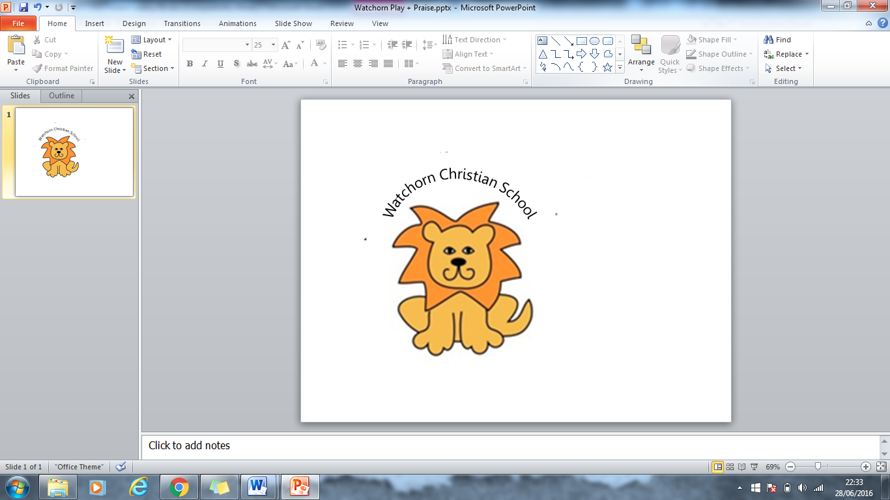
Anti-bullying Policy

This policy is based on DfE guidance “Preventing and Tackling Bullying” July 2017 and supporting documents and the DfE statutory guidance “Keeping Children Safe in Education” 2025. This policy has regard to DCSF guidance: ‘Safe to Learn: embedding anti-bullying work in schools.’

Purpose
At Watchorn Christian School, we are committed to providing a caring, friendly and safe, Christian environment for all of our pupils so they can learn in a relaxed and secure atmosphere free from oppression and abuse. The Bible teaches us that every person is created in the image of God. (Genesis 1:26) Every person, no matter what difference including religion, age, gender, ethnic background, or social class, is to be treated equally and with respect and honour. We strive to create an inclusive environment where children feel happy and secure. We work hard to teach our children and staff to carry out the command of Jesus Christ, which was to ‘love your neighbour as yourself’ Matthew 12:31.

Bullying is an anti-social behaviour and affects everyone. All types of bullying are unacceptable and will not be tolerated at our school. All pupils should feel able to confide in somebody and when bullying behaviour is brought to our attention, prompt and effective action will be taken.

This policy seeks to:
- Raise awareness among staff, pupils, and parents about bullying
- Actively counter bullying at the school
- Develop in pupils respect and concern for others, of all races, creeds and genders
- Develop in pupils an understanding that they can make a positive contribution to ending
bullying
- Develop conflict resolution skills in pupils.
- Create a climate where it is okay to talk about bullying and ask for help.
- Develop a community environment that nurtures and promotes pupil self-esteem, self
confidence, resilience and spiritual wellbeing

Definition of Bullying or child on child Abuse

Bullying is behaviour by an individual or group, repeated over time, that intentionally hurts another individual or group either physically or emotionally.
(Preventing and Tackling Bullying, Advice for Head Teachers, Staff and Governing Bodies, DfE, 2017, p. 4)

Bullying is unprovoked aggressive behaviour deliberately inflicted by an individual or group. It
can be physical or verbal, social, individual or direct or indirect, using various mediums. It may
be a major incident, (see levels of severity of bullying incidents) or a number of less serious but
persistent incidents.

We understand that bullying can take place between pupils, between pupils and staff, or between staff; by individuals or groups; face-to-face, indirectly or using a range of cyber bullying methods. We understand that all children have disagreements with each other, and friends fall out for a time. This is not usually bullying.
Peer on peer abuse manifests itself in many ways and is taken very seriously.

Types of Bullying:

Physical Bullying: | Verbal:
Hitting  Kicking  Pushing  Spitting, biting  Pinching, scratching  Throwing things at people  Indirect  Getting another person to harm someone | mean and hurtful name calling  Hurtful teasing  Demanding money or possessions  Forcing another to do homework  Spreading nasty rumours  Trying to get other pupils to dislike another pupil
Social Intimidation: | Sexual Orientation:
Threatening and/or obscene gestures  Racist or sexist remarks  Inappropriate religious remarks to all faiths  Forcing someone to do things they don’t want to do  Deliberate exclusion from a group or activity  Removing, hiding and/or damaging another’s property | Homophobic language  Name calling (any incident perceived by the alleged)  Spreading rumours about someone’s sexual orientation  Trying to get other pupils to dislike another pupil because of their perceived orientation
Cyber (email, sms, phone and internet mediums)
Mean, belittling and hurtful name calling
Threatening and/or obscene language
Offensive images
Repeated messages
Using another pupil’s password or phone to communicate obscene language

A definition for younger children
Bullying is when these things happen again and again (a serious incident may happen just once)
to someone making it is hard for the pupil being bullied to stop these things from happening:

- Being ignored, left out on purpose, or not allowed to join in
- Being made fun of and teased in a mean and hurtful way
- Lies or nasty stories told about someone to make other children not like them.
- Being made afraid of getting hurt
- Forcing someone to do things they don’t want to
- Being hit, kicked or pushed around
- Being called hurtful names that the person doesn’t like.

Rights
- Every person has the right to feel safe. Any person who bullies another is denying them that right. This means we have to think about others in the classroom and in the playground. The right to feel safe means we have a responsibility to consider how we speak and act towards others. Bullying takes away a person’s sense of security. The right to safety means that any bullying of any kind is unacceptable.
- Every person has the right to be treated with fairness and respect. This means we show respect to other people, and their property, in the class and in the playground. The right to receive respect and fair treatment requires from us the responsibility to show manners and courtesy towards each other.
- Every person has the right to learn. This means we do not adversely affect the learning
of another student.

At Watchorn Christian School, it is everyone’s responsibility to take the necessary steps to stop bullying behaviour. The school will not tolerate any action that undermines a person’s right to feel safe, respected and to learn.

Responsibilities
Governors, Staff, and Teachers have the following responsibilities:
1) The Head Teacher and Governors of the school will aim to:
a) Support, promote, enact, maintain and review the Bullying Policy and procedures.
2) All Staff will aim to:
a) Be familiar with the School’s Bullying Policy and procedures.
b) Promote a school climate where bullying and violence are not tolerated and cannot
flourish; including on the playground at lunch and break times
3) Teachers will aim to:
a) Be models of caring and tolerant behaviour.
b) Listen and act upon reports of bullying.
c) Keep the relevant class teachers informed
d) Inform the Head Teacher of serious incidents.
e) Protect the person being bullied from further harm.
f) Act to stop the behaviour recurring.
e) work to create an inclusive, caring learning environment.
g) use curriculum opportunities to address bullying.

Pupils who are being bullied need to report the incident to a teacher or staff member.
1) Pupil bystanders to bullying should:
a) Intervene by speaking firmly to the bullying pupil if they are able to
b) Seek teacher assistance

2) Parents should:
a) Listen sympathetically to reports of bullying
b) Speak to school personnel (not the alleged pupil/s concerned)
c) Work with the school in seeking a permanent solution
Why is it important to respond to bullying?

Bullying hurts. No one deserves to be on the receiving end of bullying. Bullying has the potential to damage a person, and everybody has a right to be treated with respect. Pupils who are bullying need to learn different ways of behaving.

Procedures for dealing with bullying:
Different procedures will be followed depending on the severity of the situation. The severity of the situation can be judged based on the following factors:
- The duration of behaviour
- The frequency of behaviour
- The type of bullying behaviour

Least severe - low level
This behaviour generally involves thoughtless acts that happen occasionally. This type of behaviour may not be classed as bullying but will be dealt with appropriately as it can escalate to become more serious. Adults dealing with low level bullying should adopt strategies from the following list as appropriate:
- We will interview the pupil (or pupils) involved in bullying separately.
- We will listen to their version of events.
- We will talk to anyone else who may have witnessed the bullying.
- We will reinforce the message that bullying is not acceptable, and that we expect bullying to stop.
- We will seek a commitment to this end.
- We will affirm that it is right for pupils to let us know when they are being bullied.
- We will adopt a joint problem-solving approach where this is appropriate, and ask the pupils involved to help us find solutions to the problem. This will encourage pupils involved to take responsibility for the emotional and social needs of others.
- We will consider sanctions under our school’s Behaviour & Rewards Policy.
- We will advise pupils responsible for bullying that we will be checking to ensure that bullying stops.
- We will ensure that those involved know that we have done so.
- We will reinforce the classroom rules and make sure that the child understands the expectations of behaviour
- We will talk to the child about how their behaviour can make others feel.
- We will talk to the child about saying sorry.
Serious – medium level
The behaviour is considered serious when it has been going on for some time and has become
systematic and hurtful to the person being bullied. Bullying behaviours at this level need to be
dealt with by behaviour support strategies that should include consequences for actions and
behaviour support to assist the child with behaviour change. The Head Teacher will usually be
informed. In these cases, the following procedures will be adhered to (in addition to the procedures above):
- Child will be removed from the class until the incident has been investigated
- Withdrawal of break and lunchtime privileges will be given as a sanction
- After school detention for older children may be necessary
- The head teacher will speak to the child who is doing the bullying to hear their side of the events and to give them an opportunity to understand that their actions are wrong and an apology is needed.
- The child will then be put on ‘report’ for the rest of the week to ensure that the bad behaviour does not persist.
- The child will only be allowed back into the classroom if they have shown that they regret their actions and have apologised to the victim.
- When bullying occurs, we will contact the parents of the pupils involved at an early stage.
- We will keep records of incidents that we become aware of and how we responded to them.
- We will follow up after incidents to check that the bullying has not started again.
- We will also work with pupils who have been involved in bullying others to ascertain the sort of support that they themselves need.
Severe – high level
When the behaviours have extended over a period and are intensely cruel and threatening, it is considered severe. These behaviours are persistent and can cause the person being bullied to be severely distressed. Severe cases will be referred to the Head teacher who will need to ensure the safety of all involved. Interviews need to be conducted with all individuals involved including the person bullying, the person being bullied and any bystanders. Parents of pupils directly involved in the bullying will be informed and may be involved in the process of the discussions. It is possible for a pupil who continues to be involved in high level bullying to be excluded from the school at the discretion of the Head teacher.

Guidelines for dealing with incidents of bullying:
It is imperative that:
1) The pupil/s being bullied is/are protected from further harm.
2) The bullying is stopped to ensure the safety and well-being of those bullied.
3) All staff and pupils know to whom they can report incidents of bullying.
4) The class teacher ensures that all investigations are dealt with urgently and fairly.
5) All staff are vigilant in supervision.

The response (normally the class teacher) to pupils who have bullied another is to
proceed through the following guidelines:
- Investigate what happened.
- Refer the incident if necessary.
- If appropriate interview the bystanders and discuss strategies these pupils might use to
avoid bullying in the future.
- Establish the wrongdoing and the need to change.
- Outline the disciplinary consequences imposed and the consequences that will be
imposed if the bullying continues.
- Enlist the support of parents/carers to help change the behaviour and attitude of the pupil, where appropriate.
- Regarding incidents of homophobic or gender based bullying the teacher needs to use
age-appropriate concepts and language to explain why this is not acceptable.

The response to pupils who have been bullied is to proceed through the following
guidelines:
- They will be reassured that they do not deserve to be bullied and this is not their fault.
- We will assure them that it was right to report the incident.
- We will encourage them to talk about how they feel.
- We will engage them in making choices about how the matter may be resolved.
- We will try to ensure that they feel safe.
- We will discuss strategies for being safe and staying safe.
- We will ask them to report immediately any further incidents to us.
- We will affirm that bullying can be stopped and that our school will persist with intervention until it does.
- We will involve their friends / older pupils in peer support / the buddy system/ mediation
- Provide encouragement to form and maintain friendships with non-bullying pupils.
- We will provide intervention/support for the child to build their confidence back up.
Bullying outside of the school premises:
Schools are not directly responsible for bullying that occurs off the premises, but we know that bullying can occur outside the school gates, on journeys to and from school and through social media. The bullying may be done by pupils from our own school, by pupils from other schools or by people who are not at school at all. Where a pupil or parent tells us of bullying off the school premises we will:
- Talk to pupils about how to avoid or handle bullying outside of school.
- Talk to the head teacher of another school whose pupils are bullying.
- Talk to the children involved and investigate the issue.
- Talk to the parents of the children involved.
- Talk to the police if appropriate
The DfES says that “exceptional failure to take disciplinary steps to combat harmful behaviour outside the school might breach the school’s common duty of care.” Legal Services advise that schools can take disciplinary action against pupils for incidents that occur outside of school.
Record Keeping:
It is important to record all incidents of bullying. The Head Teacher should be informed
of all incidents no matter how serious and they will record the incident and its conclusion in the incident book.

Possible signs of bullying:
The following symptoms may be associated with pupils experiencing bullying behaviour but this list is not exhaustive.
These pupils may:

- Have a decreased interest in school.
- Feel reluctant to go to school and have higher absenteeism from school.
- Perform below their ability at school.
- Frequently complain of headaches or stomach aches.
- Want to be taken to and from school or to go a new route.
- Have frequent damage to or a loss of items such as clothing, property or schoolwork.
- Have frequent injuries such as bruises or cuts.
- Be withdrawn and seem reluctant to say why.
- Have difficulty sleeping, wet the bed or have nightmares.
- Frequently come home hungry.
- Ask for extra lunch or pocket money and/or have money going missing from the house.
- Appear generally unhappy, miserable, moody and/or irritable.
- Reluctant to eat or play properly.
- Threaten or attempt to harm themself.
- Have no friends to share free time with.
- Be rarely invited to parties or other social activities with peers.

Preventing bullying by creating a caring culture:
- Classroom rules: ensuring that all children are familiar with the classroom rules of being kind and being a good friend.
- Playground buddy: assigning older children the role of ‘playground buddy.’ If a child feels lonely, they can take a seat on the ‘buddy bench’ and the ‘playground buddy’ goes and plays with them.
- Assemblies: regularly fostering a culture of kindness and acceptance through assemblies.
- Stories: reading social stories about bullying and about accepting people who may look or behave differently.
- Circle time/PHSE- talking about issues of friendship and conflict resolution in an age appropriate
way. Discussing issues around diversity and drawing out anti-bullying messages.
- Enlist the help of outside anti-bullying organisations and police resources.
- Discuss cyber bullying and keeping safe online during ICT lessons.
- Taking part in the annual Anti-bullying week (November).
- Visit from the anti-bullying governor
- Safety survey with children- annually at least
- Ensure all staff are aware of the anti-bulling policy and procedures.
- Provide staff training during staff meetings annually.
- Involve children in the writing of the anti-bullying policy in an age-appropriate way.
- Celebrate the school’s anti-bullying and friendship success.

Concerns and complaints:
We recognise that there may be times when parents feel that we have not dealt well with an incident of bullying, and we would ask that this be brought to the head teacher’s notice. If the head teacher cannot resolve these concerns informally, parents can raise their concerns more formally through the school’s Complaints Procedure a copy of which may be obtained from the school office. We would also be pleased to receive Compliments – feedback from parents when things have gone well.

Advice to parents:

- Listen to your children if they raise a concern about being bullied at school.
- Advise your child to tell a trusted adult in school or contact the class teacher yourself to share what you have learnt.
- The bullying behavior will be investigated.
- The Class Teacher or a member of SLT will make contact with all parents of the children involved to inform them of what the school is doing to resolve the bullying concern.

Please DO NOT act by yourself by:

- Attempting to sort the concern out yourself by speaking to the child who you think may be the bully or by speaking to their parents.
- Encourage your child to be a ‘bully’ back.

Both of these will only make the problem much harder to solve.

Further Support can be found on the Derbyshire Schools Net
https://schoolsnet.derbyshire.gov.uk/keeping-children-safe-in-education/anti-bullying/bullying-behaviour.aspx

Evaluate and review : We will evaluate our anti-bullying policy using the following measures:
- The numbers of incidents that are reported to staff over a given periods.
- Pupils’ perceptions of bullying in school through structured discussions in class time.
- The number of days of absence which are thought to arise as a consequence of bullying.
- We will investigate patterns of absence to ensure that children are not taking unnecessary days off school due to fear of being bullied.
- The number of complaints and compliments that we receive from parents.
- From the comments made by visitors and other people connected with the school.

This policy was reviewed by the schools Governing Body on 29.09.2025 and will be reviewed annually.

