

Marking Policy

Introduction
At Kingdom Christian School, we recognise that high-quality marking and feedback are central to effective teaching and learning. The way in which pupils’ work is acknowledged and responded to has a significant impact on their progress, motivation, and attitudes to learning.
Marking and feedback at our school are designed to be meaningful, manageable, and motivating. They provide clear guidance to pupils on how to improve, while also informing teachers’ planning and assessment. This policy ensures a consistent approach across the school that supports all pupils in making sustained progress.

Aims
This policy aims to ensure that marking and feedback:
- are consistent and of high quality across the school,
- support pupils in understanding what they have done well and what they need to do next,
- address misconceptions and move learning forward,
- promote pupil independence through reflection and response,
- inform teaching, assessment, and future planning,
- contribute to raising standards and improving outcomes for all pupils.

Principles of Effective Feedback
At Kingdom Christian School, effective feedback:
- is timely and relevant to the learning objective,
- focuses on moving learning forward rather than simply correcting work,
- is adapted to meet the needs of individual pupils,
- may be verbal or written, depending on what is most effective,
- includes opportunities for pupils to respond and improve their work,
- encourages self-assessment and peer assessment to develop independence,
- is clear, concise, and purposeful to ensure it is manageable for staff.

Marking Expectations and Procedures
General Expectations
- All work will be acknowledged in line with this policy.
- Marking will relate directly to the learning objective and success criteria.
- Teachers will use their professional judgement to determine the most appropriate form of feedback.
- Live marking is encouraged as it has the greatest impact on pupil progress.
- Where live marking is not possible, work will be marked promptly.
- Evidence of teacher support, intervention, and challenge should be visible in pupils’ books over time.

Marking Format
- Teachers will mark using green ink.
- A consistent set of marking symbols will be used across the school.
- Feedback will include:
  - acknowledgement of what has been achieved,
  - identification of errors or misconceptions (where appropriate),
  - clear next steps to move learning forward.

English
- Teacher conducts in-depth marking each half term using our marking template which is stuck in the children’s English books.
- Work is reviewed for progress and increased attainment.
- Work is reviewed for any consistent errors.
- Targets are set for the child to work towards, and this is reviewed at the next in depth marking.

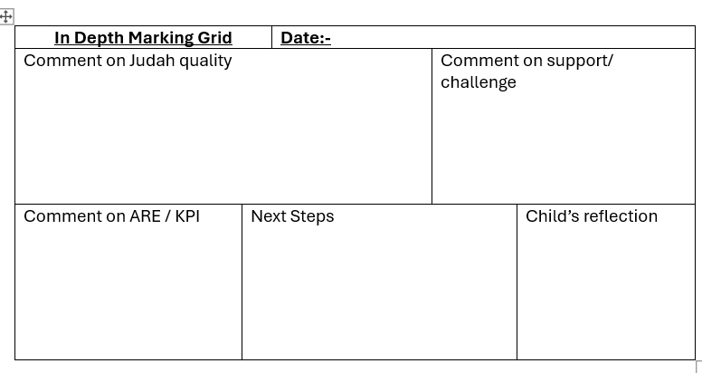
Mathematics
- A tick (✓) indicates a correct answer.
- A dot or cross indicates an incorrect answer.
- Pupils are expected to review and correct errors promptly to consolidate learning.

Pupil Response and Reflection
- Pupils will use purple pen to:
  - respond to teacher feedback,
  - complete corrections,
  - engage in self and peer assessment.
- Dedicated time will be planned for pupils to read, reflect, and respond to feedback.
- Pupils will self-assess their understanding of the learning objective at the end of lessons where appropriate.

Assessment and Impact
- Marking and feedback will be used formatively to inform day-to-day teaching and planning.
- Evidence from pupils’ work will contribute to summative assessments and reporting.
- The impact of feedback will be seen in pupils’ ability to correct errors, improve work, and apply learning independently.

Monitoring and Evaluation
The implementation and impact of this policy will be monitored through:
- regular book scrutinies,
- lesson observations and learning walks,
- pupil voice and discussions about feedback,
- planning scrutiny,
- assessment outcomes and progress data.
Senior leaders will ensure that marking is:
- consistent across classes and subjects,
- having a positive impact on pupil progress,
- manageable and sustainable for staff.
Feedback from monitoring will be used to provide support, training, and further development where needed.

Roles and Responsibilities
Teachers:
- implement the policy consistently,
- provide effective, timely feedback,
- plan opportunities for pupil response,
- use assessment information to inform teaching.
Senior Leaders:
- monitor consistency and impact,
- provide guidance and professional development,
- ensure workload is manageable.
Pupils:
- engage with feedback and act upon it,
- take increasing responsibility for improving their work,
- participate in self and peer assessment.

Review
This policy will be reviewed annually to ensure it remains effective, up to date, and aligned with current best practice and statutory expectations.

Version control table
Version | Date | Changes | Approval
1 | 2026 | Re-branded to KCS. Formatting. | SO

