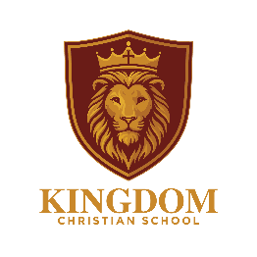

PROMOTING FUNDAMENTAL BRITISH VALUES POLICY

Introduction

At Kingdom Christian School we believe it is the duty of every member of staff to ACTIVELY PROMOTE British values and to actively challenge the expression of views which disagree with them.

Each of the four aspects of British values are defined in this policy and placed in a school context using examples. This Policy has been written in accordance with the related government guidance including:

• The Prevent Duty (2023)
• Promoting British Values as part of SMSC in schools (2014)
• Improving the spiritual, moral, cultural and social (SMSC) development of pupils.

This policy should be read in conjunction with the schools Safeguarding and Child Protection policy.

School Ethos
Kingdom Christian School approaches the promotion of British values in line with the Government’s PREVENT duty and SMSC curriculum. This is coupled with our Christian Faith, where compassion, respect, tolerance and unconditional love of all people are foundational to what we believe.

These can be summed up by the following scripture from the Bible:
Matthew 22:36-40 New International Version (NIV)
“Teacher, which is the greatest commandment in the Law?”
Jesus replied: “‘Love the Lord your God with all your heart and with all your soul and with all your mind.’ This is the first and greatest commandment. And the second is like it: ‘Love your neighbour as yourself.’ All the Law and the Prophets hang on these two commandments.”

Jesus goes on to define ‘neighbour’ as including those of different ethnic and religious backgrounds in the ‘Parable of Good Samaritan’ found in Luke 10:25-37

Procedures
British Values are defined as:
1. Democracy;
2. Individual liberty;
3. The rule of law;
4. Mutual respect and tolerance of those with different faiths and beliefs (also the duty to promote tolerance of those with protected characteristics under the Equalities Act 2010).

By the teaching of British values, we want our pupils to:

• Respect civil and criminal laws of England
• Accept responsibility for their own behaviour
• Be considerate and understand how they can serve others
• Contribute towards the society in which they live
• Be confident about their own faith and culture – know how to express it in a loving and considerate fashion
• Understand that modern Britain is a multi-cultural society
• Be tolerant and respectful to those with differing values and beliefs.
• Excel in the Fruits of the Holy Spirit as defined in Galatians 5:22

At Kingdom Christian School we hold the belief that all curriculum areas can contribute to the promoting of British Values and enhance the spiritual, moral, cultural and social development of pupils. Therefore, all curriculum areas provide opportunities for children to:

• Talk to each other
• Develop an awareness of treating all as equals, accepting people who are different because of faith/belief and cultural differences
• Agree and disagree
• Experience good role models
• Take turns and share ideas, equipment and peers
• Work co-operatively and collaboratively

British Values are also promoted through the ethos of the school, our whole school approach to behaviour and reward, our school council and assemblies. This is detailed below under each heading.

Democracy
Democracy can be seen as a state of society characterised by equality of rights and privileges. It can also refer to our nation’s electoral systems.
In school we promote the importance of democracy through a variety of ways, such as-
• Dedicated Citizenship lessons which cover a range of topics in relation to democracy in all forms.
• Assemblies.
• Pastoral groups working cooperatively during off timetable activities.
• Class votes on what to have for their marble jar treat and which class book to read.
• class votes for things special to the children such as the class names.

Individual Liberty
Individual liberty suggests the free exercise of rights generally seen as outside of Government control.
Pupils are actively encouraged to make choices at our school, knowing that they are in a safe and supportive environment. As a school we provide boundaries for our children to make choices safely, through the provision of a safe environment, a planned curriculum and open-ended play opportunities. Pupils are given the opportunity to make their opinions known through our student council which allows the children to raise issues and debate the outcomes. Teachers and governors take the views of the pupils into account.
Pupils are encouraged to know, understand and exercise their rights and personal freedoms and are advised how to exercise these safely, for example through our e-Safety teaching. Pupils are given the freedom to make choices, e.g. signing up for extra-curricular clubs, choosing resources and games at lunch times.
Pupils learn about human rights and the importance of good choices through our history, R.E and PHSE lessons which cover World War 2 etc.
Rule of Law
All people and institutions are subject to and accountable to law that is fairly applied and enforced.

In school we promote the importance of the rule of law through such things as:

• There is shared classroom code of practice for teachers and students.
• Classroom behaviour expectations are written with the children and include the issues that are important to them.
• Our behaviour thermometer system which brings about a consequence for positive and negative behaviour.
• We have high expectations of pupil conduct and this is reflected in our Behaviour Policy.
• In PHSE/circle time, children study how the law is there to keep us safe and the consequences of breaking the law (including the 10 Commandments
•We organise visits from authorities such as the police and fire service.

All of this is under pinned by Romans 13:1-7, where God’s word teaches that we should respect the law of the land.

Mutual Respect
In school we promote the importance of mutual respect through such things as:
• Promoting tolerance of those with protected characteristics under the Equalities Act (2010) and challenging any expression of intolerance.
• Classroom code of practice.
• Ethos and values of the school.
•Primary pastoral groups develop cooperation and empathy; working together with others of a different age.
• Consistent boundaries and expectations for behaviour
• Assemblies on ‘loving your neighbour as yourself’.
• Listening to opposing viewpoints during student council.

Acceptance of those with different views and beliefs
This is achieved through enhancing pupils’ understanding of their place in a culturally diverse society and by giving them opportunities to experience such diversity in our local community. Collective Worship and discussions involving prejudices and prejudice-based bullying have been followed and supported by learning in RE and PSHE. We use opportunities such as the Olympics and World Cup to study and learn about life and culture in other countries.
We have visitors from other cultures to teach the children. We recently had a staff member from Nigeria, teach the children all about Nigerian culture and cook a Nigerian meal with them.
We have a ‘wonderful world’ week every year where the children are immersed in the traditions and norms of another country and experience how people live across the World.
As a Christian school we aim for our children to develop a ‘servant heart,’ striving to show the love of Jesus to all people, regardless of their creed or colour. We aim for our children to be able to explain their beliefs lovingly and respectfully without malice and with an understanding that their view may not be shared by others, but that it is still valid.

Please see the posters of how British Values are promoted at Kingdom Christian School:

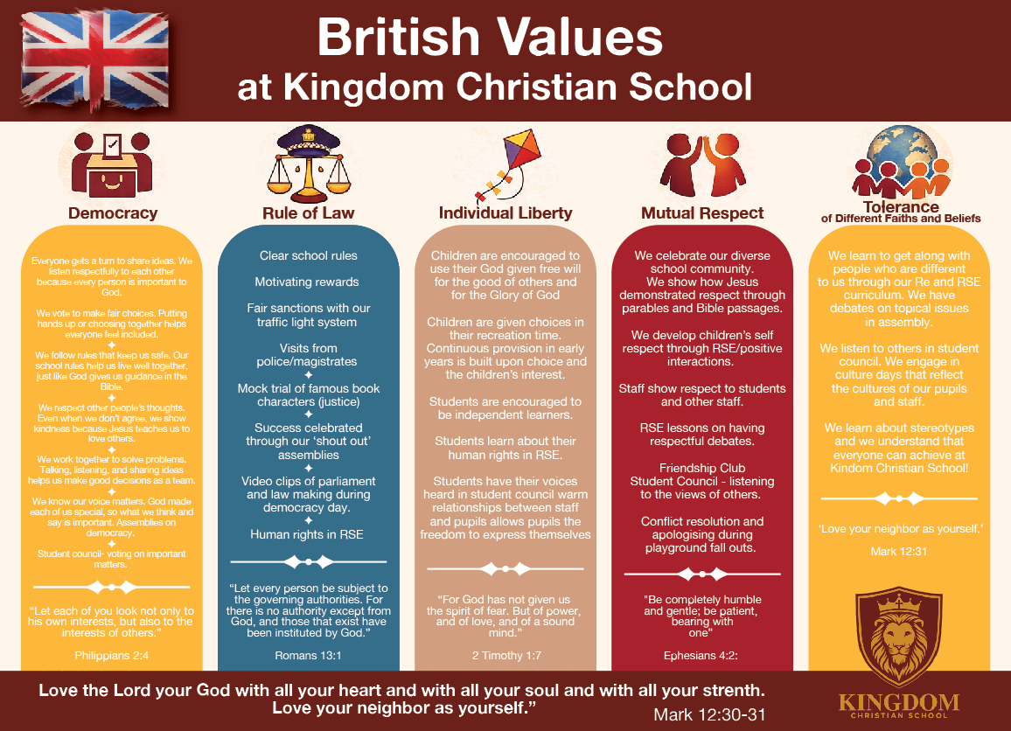

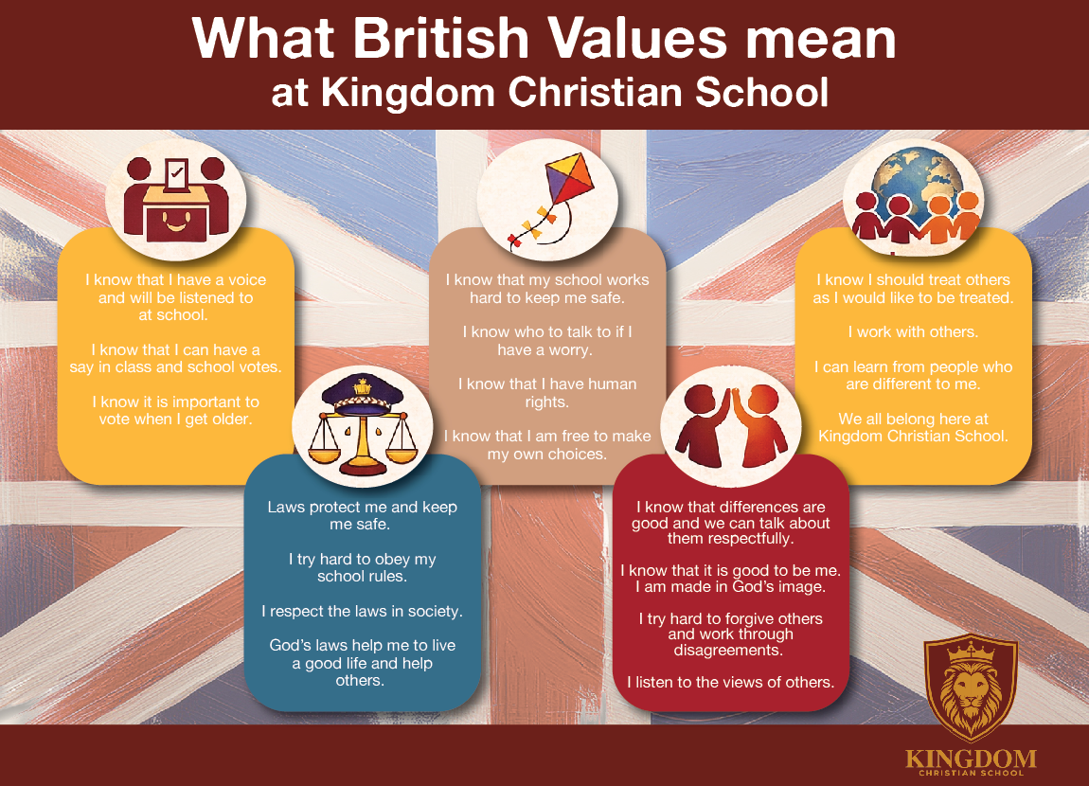

Version control table
Version | Date | Changes | Approval
1 | 2026 | Re-branded to KCS. Formatting. | SO

