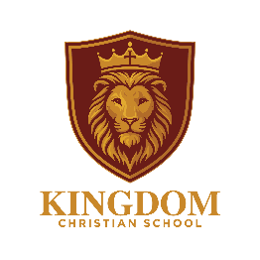

Curriculum Policy: Handwriting

1 Introduction

The ability to write fluently and legibly gives children a means to communicate their thoughts and ideas efficiently. Children’s self-esteem and confidence is increased when they are able to produce well-presented work of which they can be proud. When handwriting is automatic, the brain can concentrate on content, likely resulting in improved pupil progress in other curriculum subjects.

2 Aims and Objectives

In handwriting, as in other skills, children will develop at different rates and we hope that children will aim to continue to use their God-given potential. It is important that there is a consistent style of handwriting throughout the school, and that all staff consider themselves to be teachers of handwriting, with a clear understanding of the progression of skills, and of how to remedy errors. The different elements of handwriting need to be taught and practised. The school handwriting style is based on “Kinetic Letters”. A reference sheet showing an alphabet of capital, lower case and joined letters is included in the appendix and should be available to children in every classroom, and to parents. Further information on the “Kinetic Letters” approach is also included in the appendix.

As a school our aims in teaching handwriting are that the pupils will:

• Understand the importance of clear presentation in order to communicate meaning.
• Take pride in the presentation of their work, developing handwriting with a sense of enjoyment and achievement.
• Be able to write quickly to aid expressing themselves creatively and imaginatively across the curriculum and for a range of purposes.
• Develop a fluent, comfortable, legible joined handwriting style.

In order to achieve our aims, we intend that:
• Handwriting will be taught daily through the Kinetic Letters scheme.
Teaching will follow the planning in the kinetic letters handbook, working their way through the letter families. The class teacher/teaching assistant will move the children on to the next letter family as appropriate.

Children who require extra support with handwriting will have handwriting intervention where appropriate.

• In Foundation Stage and Key Stage 1 the focus will be upon improving core strength, motor and spatial preparation, learning the letters and holding the pencil.
In year 2 the children will move on to improving flow and fluency, leading to confident letter formations and joining when appropriate.
• Regardless of which hand the children prefer to write with, they should have no greater difficulty in learning to write.
• Children in Foundation Stage and Key Stage 1 will begin using sand trays and whiteboards when forming their letters.
• Children in Key Stage 2 will begin by forming their letters on whiteboards and move on to handwriting paper, where the middle line is already drawn in. Once they have mastered the cursive style of writing, they will move on to practising their handwriting in a lined exercise book without smaller lines in between.
• Handwriting will be assessed termly. The children write the phrase ‘The quick brown fox jumps over the lay dog.’ This phrase is used as it contains all the letters of the alphabet, therefore letter formation can be assessed and target points given.
• In Key stage 2, when children have achieved legible joined handwriting in pencil, they will progress to a fibre tip, “school handwriting pen”, which will then be used for all written work in school. All children in upper Key stage 2 will use a handwriting pen.

Appendix 1:

The Kinetic Letters handwriting scheme promotes:
• Automaticity – Formation, orientation and placement of letters becomes automatic which frees up space in the working memory.
• Achievement – Fast, legible and fluent handwriting underpins success in every curriculum area.
• Confidence – Good handwriting creates a positive initial judgement.
• Creativity – When handwriting is automatic, the brain can concentrate on content.
• Reading – Writing and reading are reciprocal skills, so improvement in one, helps the other.
• Phonics and Spelling – legible handwriting means children can read and correct spelling.

Appendix 2 Handwriting Paper
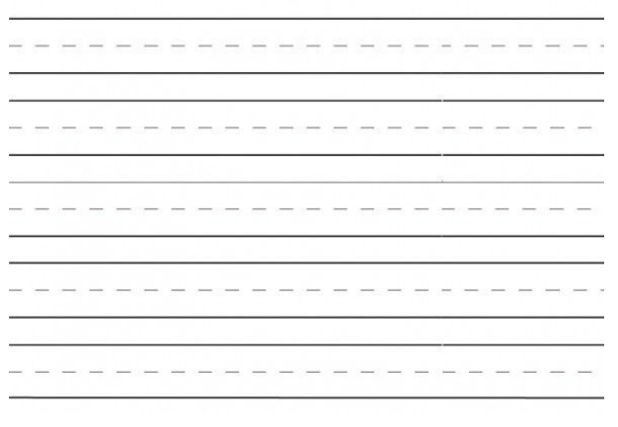

Appendix 3 – Letter Formations

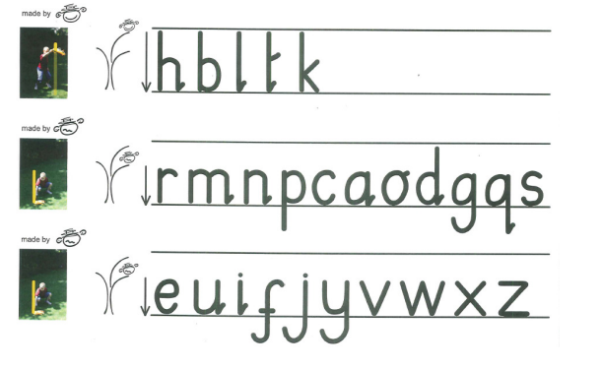

Appendix 4 – Letter Families

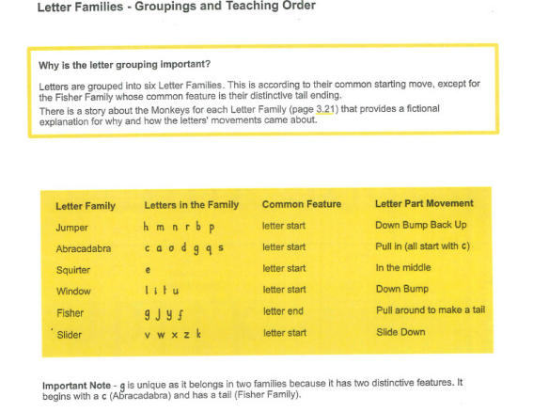
Appendix 5 – Teaching Order
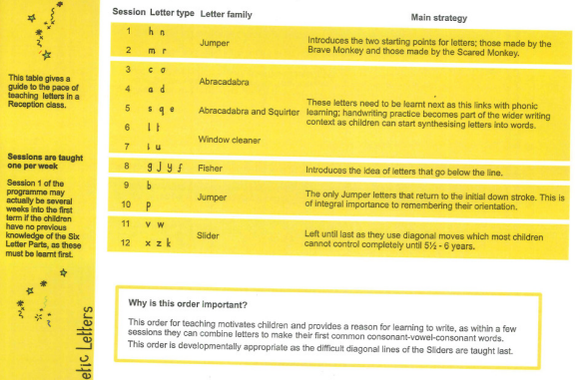

Appendix 6 – Stories Associated with Letter Families

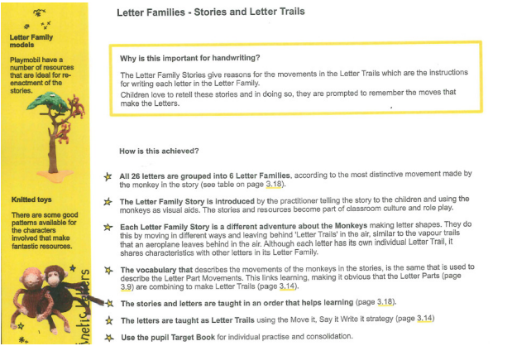

Appendix 7 – Letter Families (Close up)
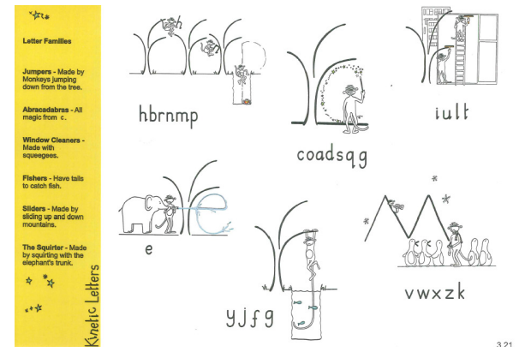
Appendix 8 – Letter Families (Close up)

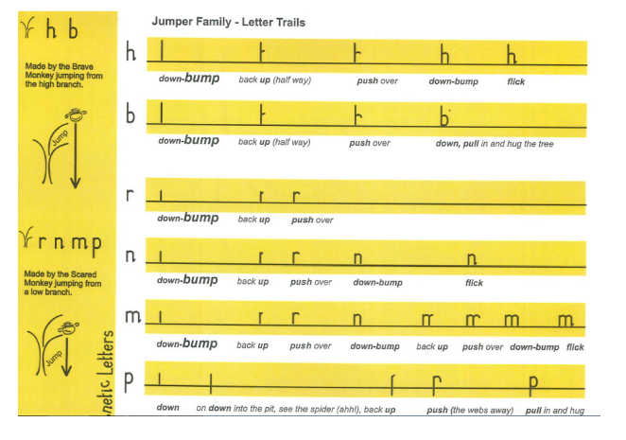

Appendix 9 – The Abracadabra Family

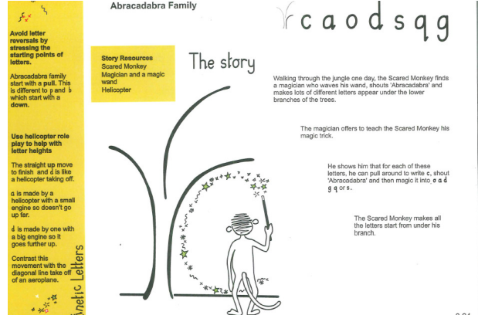

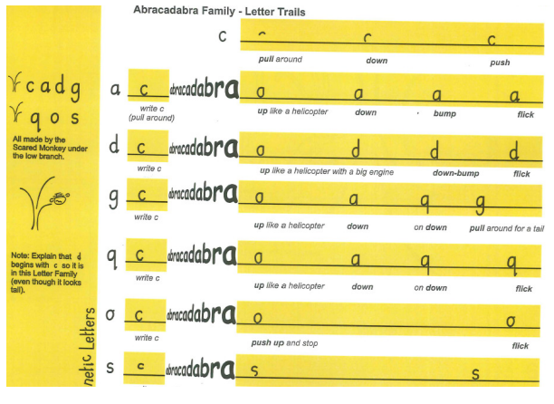

Appendix 10 – The Special Squirter

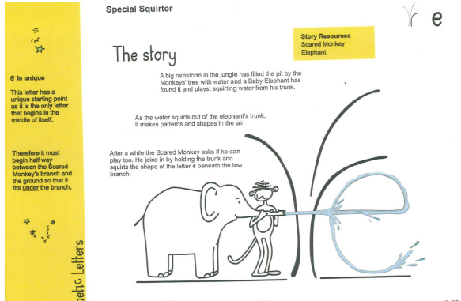

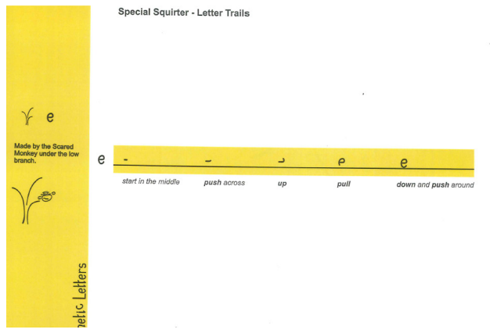

Appendix 11 – The Window Cleaner Family

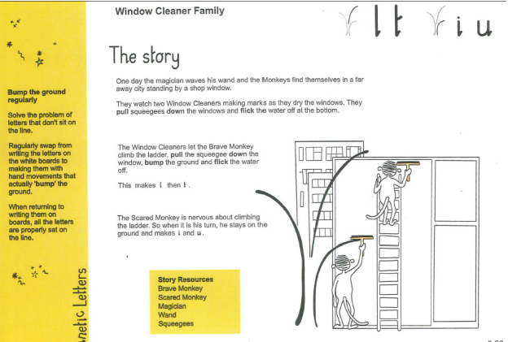

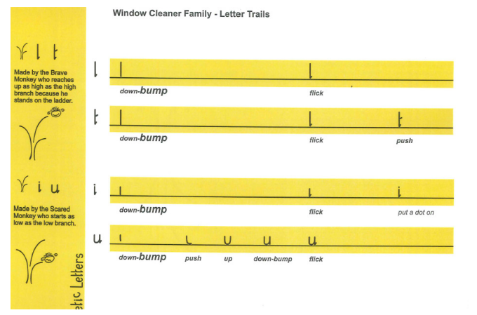

Appendix 12 – The Fisher Family

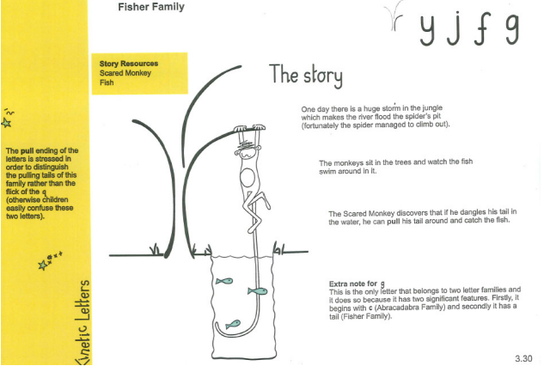

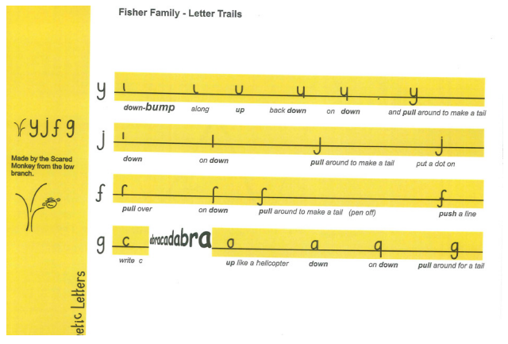

Appendix 13 – The Slider Family

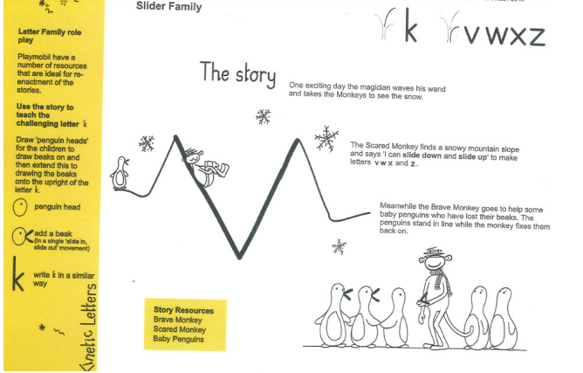

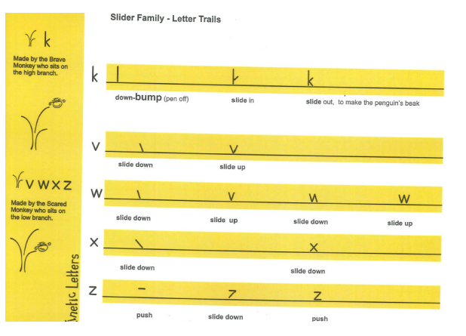

Appendix 14 – Teaching Joining

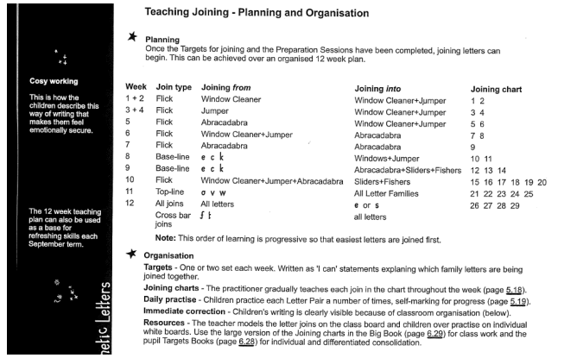

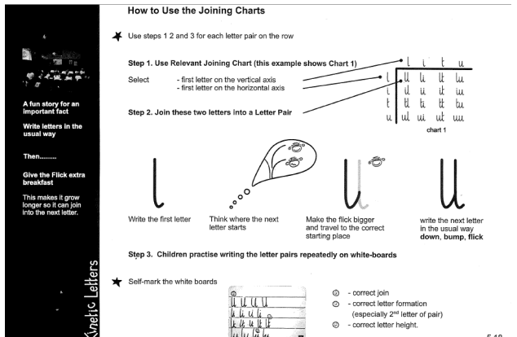

Version control table
Version | Date | Changes | Approval
1 | 2026 | Re-branded to KCS. Formatting. | SO

