Relationship and Sex Education Policy

Date of last review: 24/08/2026
Date of next review:24/08/2027
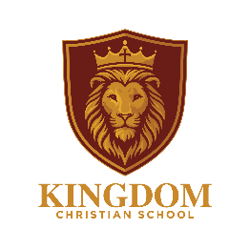

RELATIONSHIP AND SEX EDUCATION POLICY

1. Introduction
In this policy, the Governors and teachers, in partnership with pupils and their parents and carers, set out our approach to Relationships and Sex Education (RSE).
RSE is an important part of our commitment to educating the whole child – spiritually, physically, intellectually, morally, socially and emotionally. We aim to equip pupils with the knowledge, understanding, values and skills they need to develop healthy relationships, make responsible choices and keep themselves and others safe.
We have consulted parents about this policy and the RSE curriculum via a parent survey (16th October 2020) and again when the curriculum was updated July 2026 questionnaire. We have consulted staff during a staff inset on RSE (23rd October 2020) and again September 2026 and provided training on the new curriculum resource. Governors have been consulted at every stage of the writing of this policy.
This policy will be reviewed every year by the Head teacher, RSE Co-ordinator, the Governing Body and Staff. It will be reviewed next in September 2026.

2. Legal Framework
This policy has regard to relevant legislation and statutory guidance, including:
- Education Act 1996
- Education Act 2002
- Children and Social Work Act 2017
- Equality Act 2010
- Keeping Children Safe in Education
- DfE Relationships Education, Relationships and Sex Education (RSE) and Health Education statutory guidance
- National Curriculum requirements for Science.

3. Our Christian Approach
“I have come that you might have life and have it to the full.” – John 10:10
Our approach to RSE is rooted in our Christian beliefs about God and the dignity and value of every human person.
We believe that every child is created in the image and likeness of God and is worthy of love, dignity and respect. RSE therefore encourages pupils to develop positive relationships, self-respect, compassion, responsibility, honesty, kindness and care for others.
Our teaching recognises the importance of marriage and family life while respecting the different family circumstances in which children live. Every child should feel valued, respected and included.

4. Life to the Full
Following a thorough review of available RSE resources, the school has chosen Life to the Full as its principal resource.
We recognise that Life to the Full was developed within a Catholic educational context. We have carefully reviewed the programme and believe that its emphasis on the dignity and value of every person, being created and loved by God, healthy relationships, love, respect, responsibility, forgiveness, compassion and personal safety provides a strong foundation for our Christian approach to RSE.
The curriculum is delivered by covering 3 topics each year: created and loved by God, created to love others, created to live in community.
The programme also provides opportunities to draw on Biblical teaching and stories.
Our teachers are appropriately trained to use the resource and exercise professional judgement when delivering it. Teaching will remain firmly rooted in our school’s own Christian beliefs, values and mission.

5. Aims of RSE
We aim to help pupils:
- develop confidence and self-esteem;
- value themselves and others;
- understand healthy and respectful relationships;
- understand the importance of family and caring relationships;
- recognise different family structures;
- understand and care for their bodies;
- prepare appropriately for puberty and growing up;
- understand feelings and manage emotions;
- develop resilience and make responsible choices;
- understand personal boundaries and how to keep themselves safe;
- recognise unsafe or inappropriate situations;
- know how and when to seek help;
- understand online safety and the risks associated with technology;
- recognise the influence of peers and media;
- develop respect, kindness, compassion and empathy.

6. Curriculum Content
RSE is taught through discrete lessons, cross-curricular learning and the wider life and ethos of the school.
The curriculum covers the statutory areas of Relationships Education and Health Education and appropriate Sex Education.
The main areas include:

Families and People Who Care for Me
- families and caring relationships;
- different family structures;
- trusted adults;
- respect and support.

Caring Friendships
- friendship;
- kindness;
- trust;
- resolving disagreements;
- forgiveness;
- recognising unhealthy friendships.

Respectful Relationships
- respect and courtesy;
- boundaries;
- personal responsibility;
- bullying and discrimination;
- peer pressure;
- appropriate behaviour.

Online Relationships
- online safety;
- privacy and personal information;
- online friendships;
- social media;
- inappropriate content and image sharing;
- seeking help.

Being Safe
- safe and unsafe situations;
- personal boundaries;
- appropriate and inappropriate touch;
- trusted adults;
- recognising and reporting concerns.

Growing and Changing
Children receive age-appropriate teaching about:
- physical and emotional development;
- puberty;
- menstruation and personal hygiene;
- human growth and development;

7. Spiral Curriculum
Life to the Full follows a spiral curriculum. Key themes are revisited throughout a child’s time at school, with learning becoming deeper and more appropriate as children mature.
For example, children may first learn about feelings, friendship, their bodies and people who care for them. These ideas are then revisited through later learning about healthy relationships, boundaries, responsibility, online safety, puberty, growing independence and making informed choices.
This ensures that pupils build on previous knowledge rather than encountering important concepts as isolated lessons.
A curriculum overview is provided in Appendix 1.

8. Science and Other Curriculum Links
RSE is complemented by learning in:
- Science – growth, development, reproduction and the human life cycle;
- PSHE – relationships, health, wellbeing and safety;
- Religious Education – Christian teaching, Biblical stories, dignity, love, forgiveness and responsibility;
- Computing – online safety and digital relationships;
- PE – physical development, health and wellbeing.

9. Inclusion and Equalities
RSE will be taught sensitively and inclusively, taking account of pupils’ abilities, maturity, SEND needs, personal circumstances, faith and cultural backgrounds.
Teaching will be adapted where necessary so that all pupils can participate fully.
The school has regard to its duties under the Equality Act 2010 and will ensure that pupils are treated with dignity and respect.
RSE will also address bullying, discrimination, prejudice-based language and harmful behaviour.

10. Teaching and Learning
A range of age-appropriate teaching approaches may be used, including:
- discussion;
- stories and scenarios;
- reflection;
- group work;
- role play where appropriate;
- videos and visual resources;
- quizzes;
- questioning;
- distancing techniques.
Ground rules will be established to create a safe and respectful environment.

11. Children’s Questions and Sensitive Issues
Pupils will be encouraged to ask questions in a safe and respectful environment.
Teachers will answer questions sensitively and according to the pupil’s age and stage of development. Personal or inappropriate questions may need to be addressed separately.
Sensitive issues will be approached carefully within the school’s Christian ethos. Teachers will provide accurate, age-appropriate information while recognising that different viewpoints may exist.

12. Safeguarding and Confidentiality
RSE provides opportunities for pupils to learn about safety, boundaries and appropriate relationships. This may sometimes result in a safeguarding disclosure.
All staff must follow the school’s Safeguarding and Child Protection Policy and report concerns immediately to the Designated Safeguarding Lead.
Teachers cannot promise pupils unconditional confidentiality. Pupils will be told, where appropriate, that information relating to abuse or risk of harm may need to be shared with other adults to keep them safe.

13. Parents and Carers
We recognise parents and carers as the primary educators of their children and seek to work in partnership with them.
Parents will:
- have access to this policy;
- be informed about the RSE curriculum via the parent portal;
- be informed about more sensitive areas of learning;
- be invited for parent workshops on RSE topics;
- be encouraged to discuss learning with their children at home.
The school welcomes parental questions and feedback about the curriculum.

14. Right to Withdraw
Parents/carers have the right to request that their child be withdrawn from Sex Education, except for those elements which form part of the National Curriculum for Science, however, At KCS and in consultation with parents, we take the approach not to teach sex education as we feel this is best done by parents at a time that is age appropriate (which could be different for each child).
Parents cannot withdraw their child from the other parts of the RSE curriculum.

15. External Visitors
External visitors may support particular aspects of RSE but will complement rather than replace teacher-led learning.
Visitors must follow school policies, safeguarding procedures and the school’s Christian ethos.
The school will review any material from visitors to ensure that it is suitable and inline with our Christian values.

16. Assessment
At the end of each unit, Life to the full has an assessment activity to capture the progress and knowledge retention.
Other assessment may include questioning, discussion, quizzes, written activities, reflection, pupil voice and teacher observation.
Teachers will assess pupils’ understanding and identify where additional support is needed. The spiral curriculum enables teachers to build on previous learning and identify gaps in knowledge.

17. Roles and Responsibilities

Governors
Governors will:
- approve and review the policy;
- ensure statutory requirements are met;
- ensure parents are appropriately consulted;
- ensure the policy reflects the school’s Christian ethos;
- monitor the effectiveness of the curriculum.

Headteacher
The Headteacher has overall responsibility for implementation of this policy and liaison with Governors, staff, parents and appropriate agencies.

RSE/PSHE Lead
The RSE/PSHE Lead will coordinate the programme, support staff, monitor curriculum coverage, support training and contribute to review and evaluation.

All Staff
All staff contribute to pupils’ personal, social, moral and spiritual development and will act as positive role models.
Teachers delivering RSE will follow this policy, use approved resources appropriately, adapt teaching where necessary and follow safeguarding procedures.

18. Monitoring and Review
The RSE/PSHE Lead will monitor the curriculum through planning, work scrutiny, pupil voice, staff feedback and review of resources.
The programme will be evaluated annually, with feedback from pupils, parents and staff considered as part of the review process.
Governors remain ultimately responsible for the policy.

Appendix 1: Life to the Full – Curriculum Overview

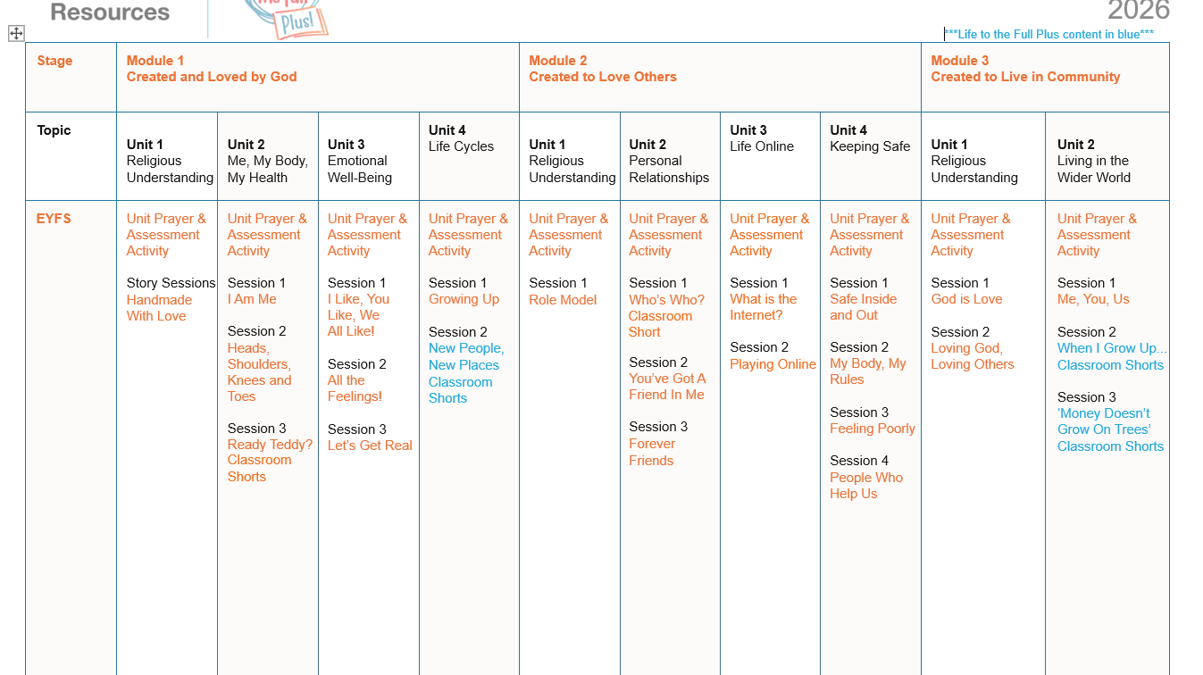
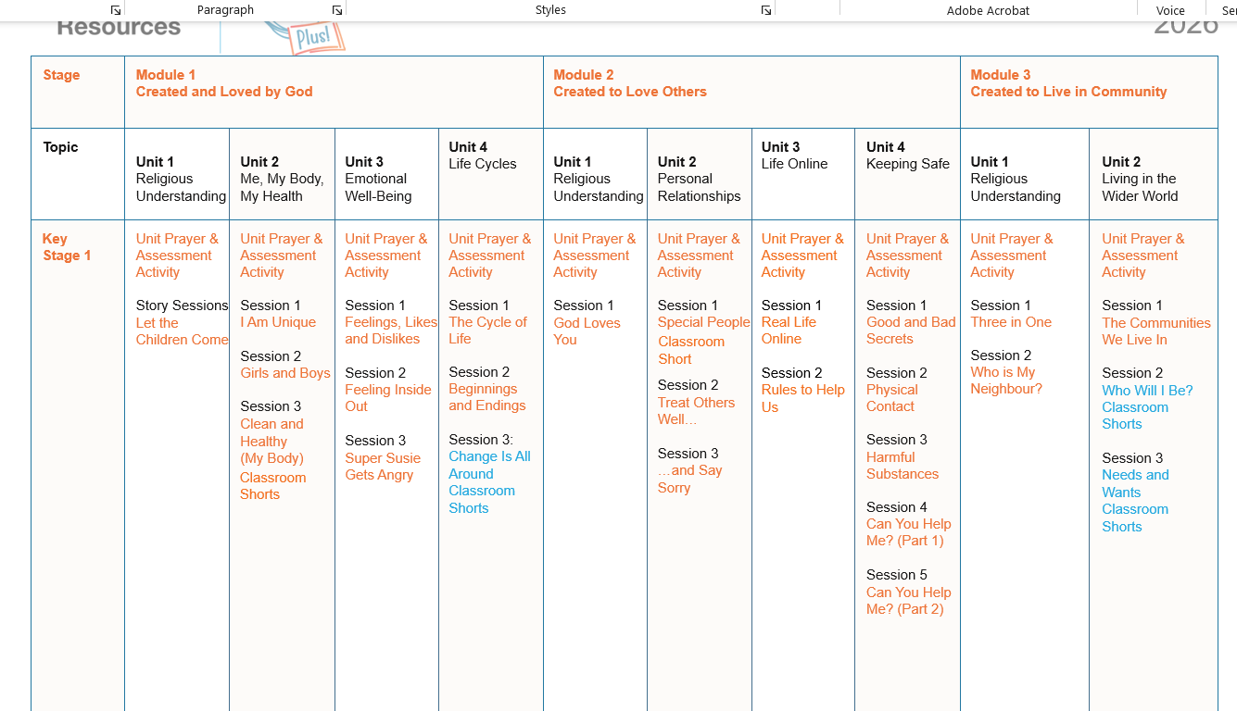

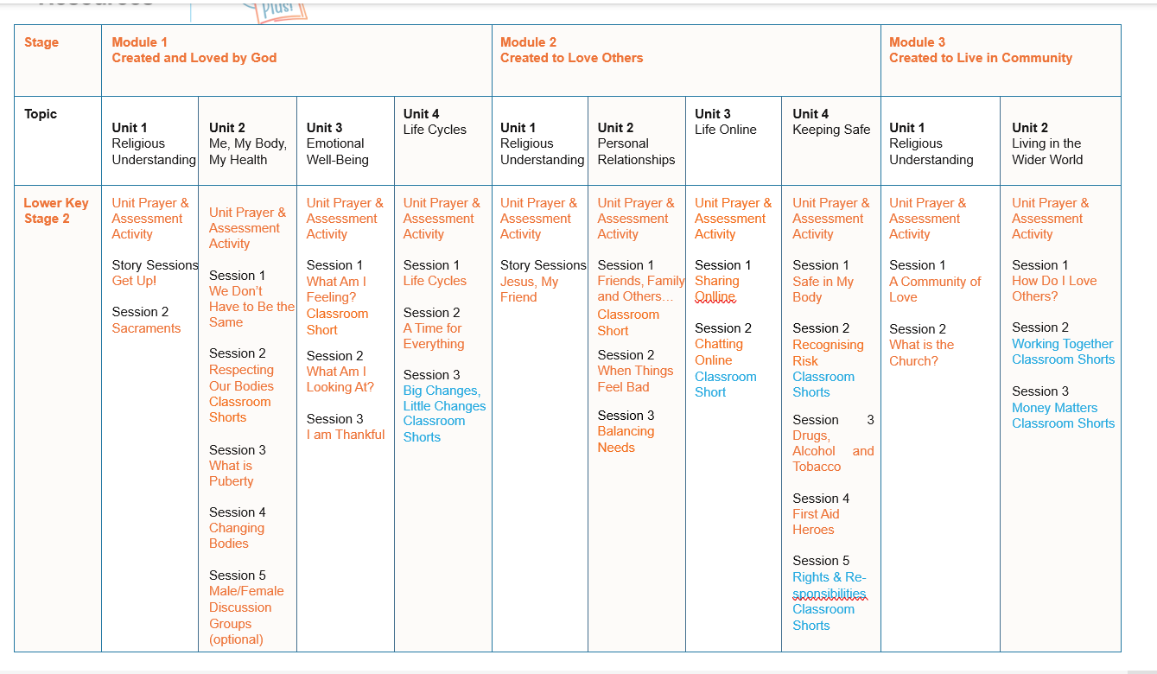

Version control table
Version | Date | Changes | Approval
1 | 2026 | Re-branded to KCS. Formatting. | SO
1.1 | 2026 | Added Life to the full material | SO
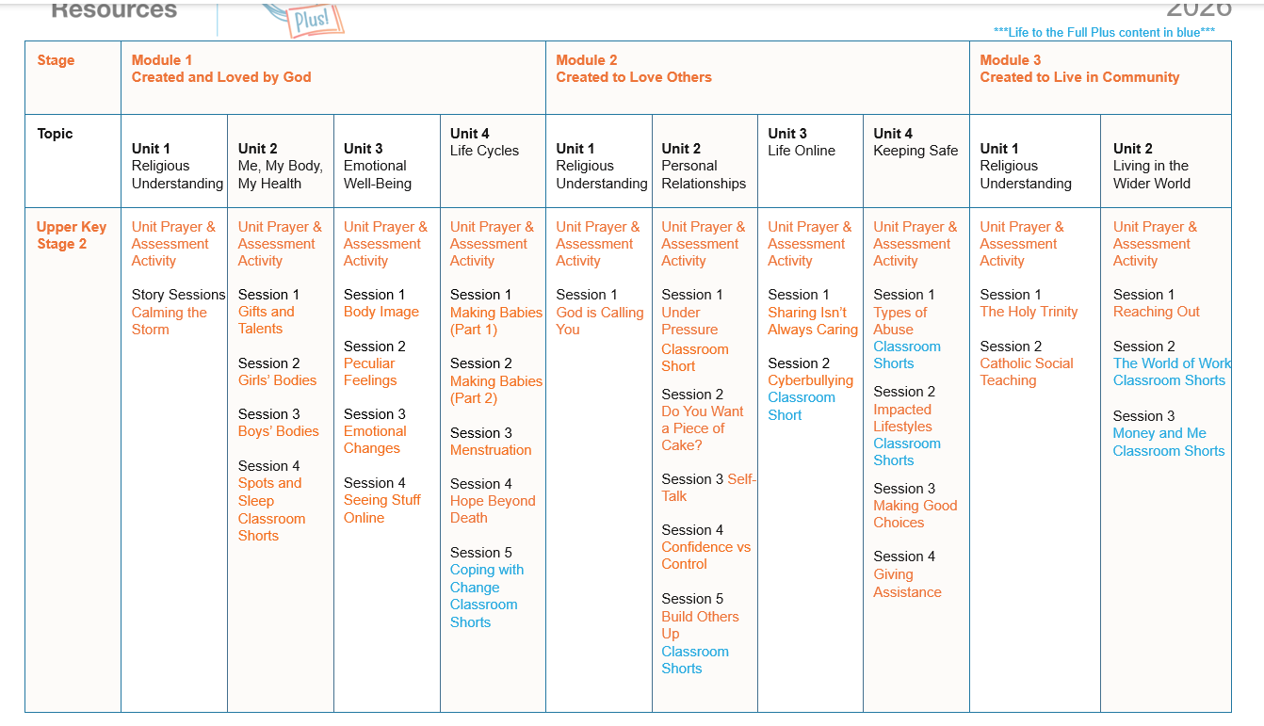


Version Control Table

